HYPER V

# Quelques commndes

## Installation rôles hyper v

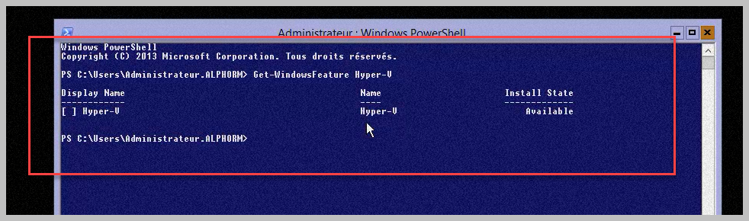

## Enabling Feature on Hyper-V

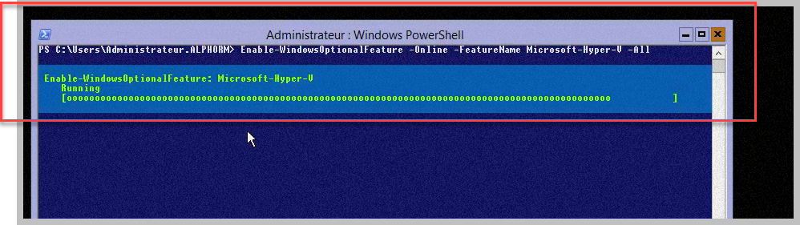

## Include some utils tools for windows Hyper V

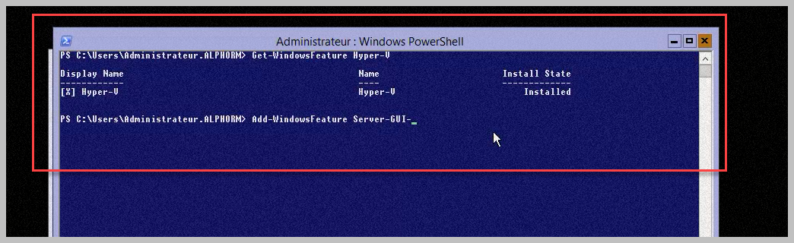

## Listing command for Hyper -v with Get-Command

Rappel :

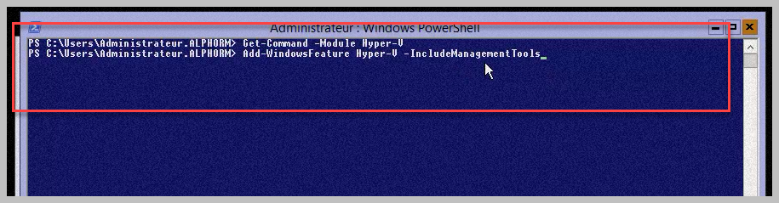

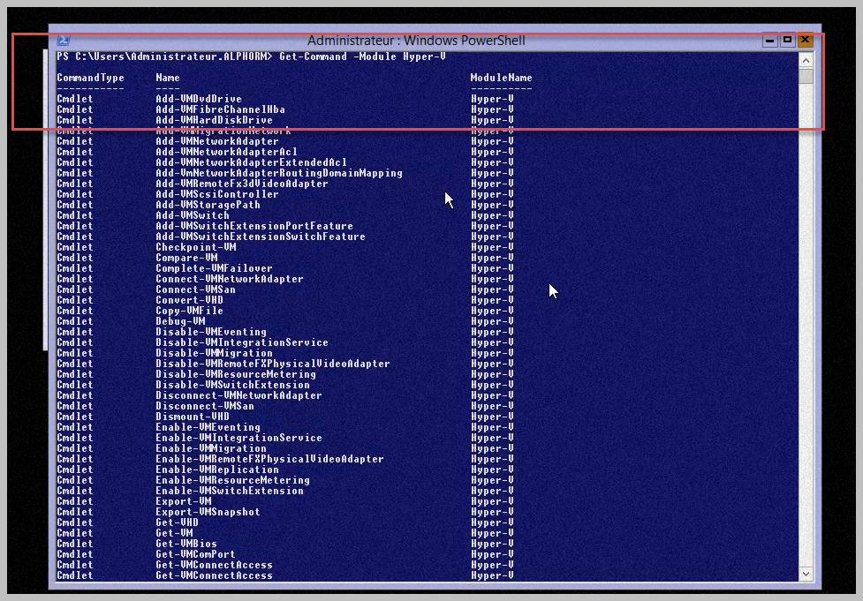

## Overview DiskPart

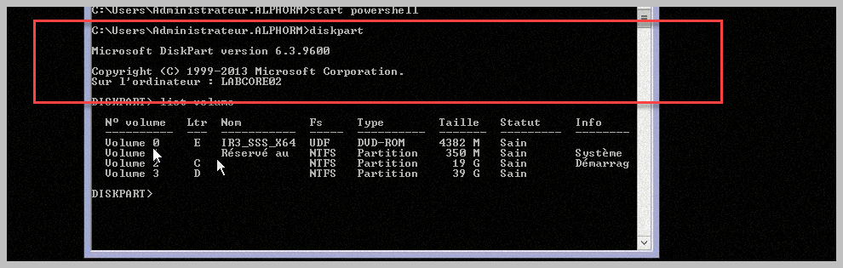

# Manipulate VMS

## Create Network

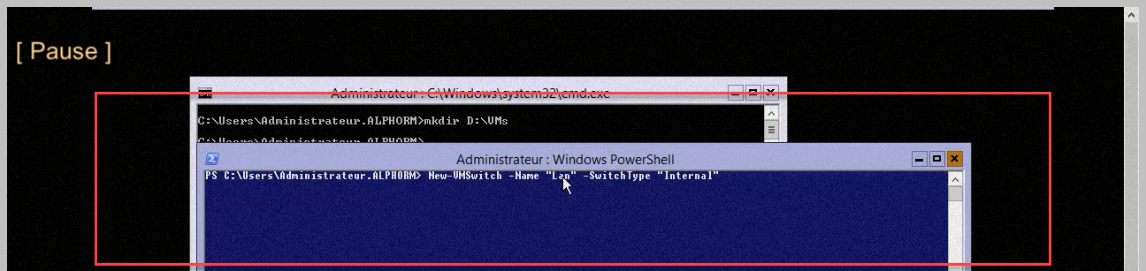

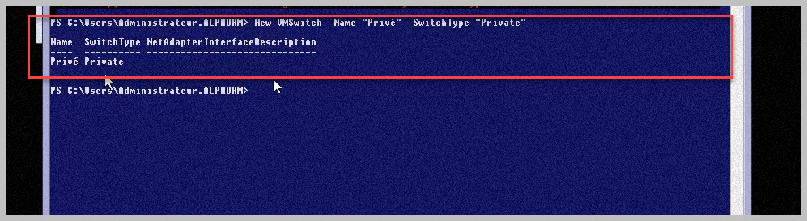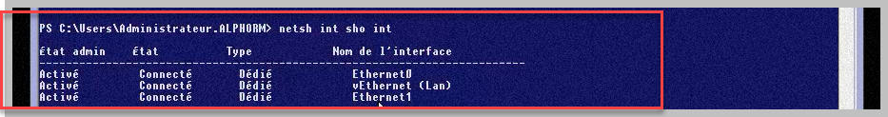

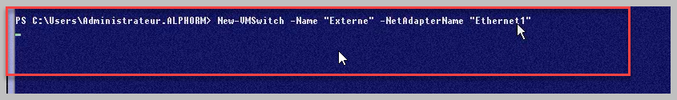

## VMS classics operation

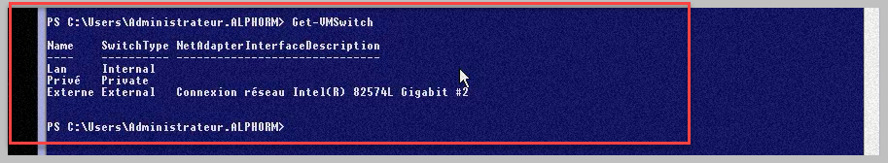

## Create VMS

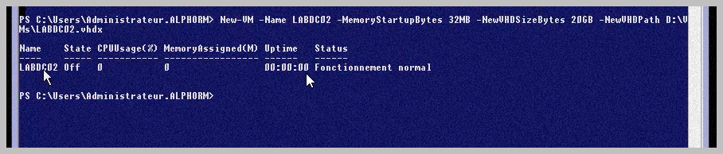

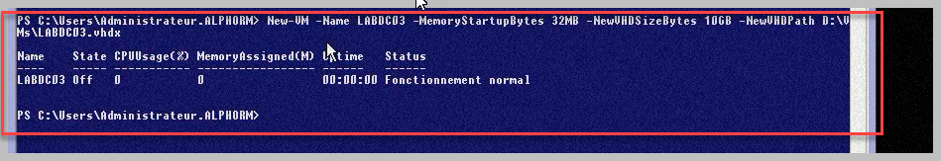

## Modify VMS

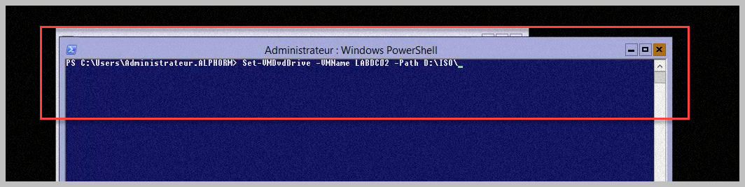

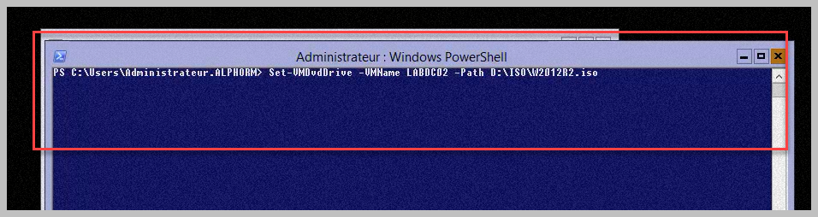

## Help and Doc

